**Parcel Data Aggregator and Analysis Tool “PDAAT”**

This is a sample of a tutorial I was putting together which will help on-board non-technical users. I started this as I wanted to send the link to others to see what we’re doing. We can discuss the acronym (PAT, PDAAT) or whatever but I’d like to move from the whimsical Pat to something more meaningful and/or professional. This will be helpful as we roll it out.

I can redo this type of tutorial later but thought it would be helpful and also gave me some screen shots that I can use to create new mock-ups and review the navigation. Here are some preliminary issues.

* Functionality. The current beta version is a great example of what we’ve done. A lot of features have been added including panning, zooming, etc.
* Limitations
  + The underlying data are still restricted to the Land Bank parcels. I would like to expand that to all of the sites using either the table I constructed from KC-MO and Jackson County data. That will make it more useful for some potential “customers” and give us more feedback when the beta goes live.
  + As noted below, once a site is added to the Folder, the base data are displayed and the more detailed data can be accessed. The problem is the screen cannot be cleared as it was earlier so properties can be added.
  + The Street View that Josh demonstrated is not active, at least not automatically by Google or Leaflet.

To Dos

* Mockup. We should look over the core screens and make some suggestions on content, layout/presentation, etc. I can see a lot of potential for this tool.
* Data. We can review and discuss the core data in light of the new access it looks like we might get from Jackson County to make sure we display the key items of interest.
* Folders. We need to put the ability to add more sites back into the system, along the lines of the aggregator we discussed on Monday.
* Street view. The ability to look at a site and surroundings that Josh demonstrated was a great feature that will make it easier for those not physically at a site to understand the environs.

The following is a draft of a tutorial we might prepare for users. It could also feed the README and Wiki pages by cutting and pasting, etc. If you think it would be worthwhile, I will add picture captions, table of contents, and other items to dress it up a bit. The can be a collaborative document as well.

**Introduction**

The Parcel Assessment Tool which is effectively a “Parcel Data Aggregator and Analysis Tool” (PDAAT) -formerly known as PAT- is designed to provide great access to data related to individual parcels (i.e., sites) in Kansas City MO, drawing on publicly available data from KC-MO, Jackson County MO, and other sources (e.g., Department of Census). While these data could be compiled by individuals using current resources, the process is cumbersome with a relatively steep learning curve. The process is more complicated when the goal is to convert the disparate data to information regarding acquisition, development, redevelopment, revitalization, and investment decisions. Simply stated, the goal of PDAAT is to simplify the process and provide access and decision support to a range of potential users, both public and private.

Accessing Beta Version of PDAAT

Go to: <https://github.com/UMKC-Law/Parcel-Assessment-Tool>

Once there, you’ll see the following image. Click on the http link to open the tool.

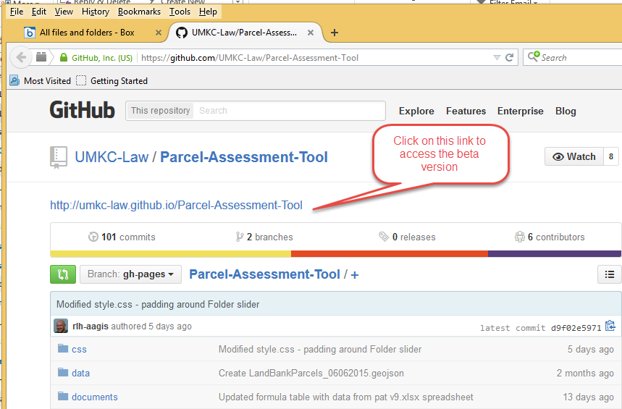

Review Introduction and access system

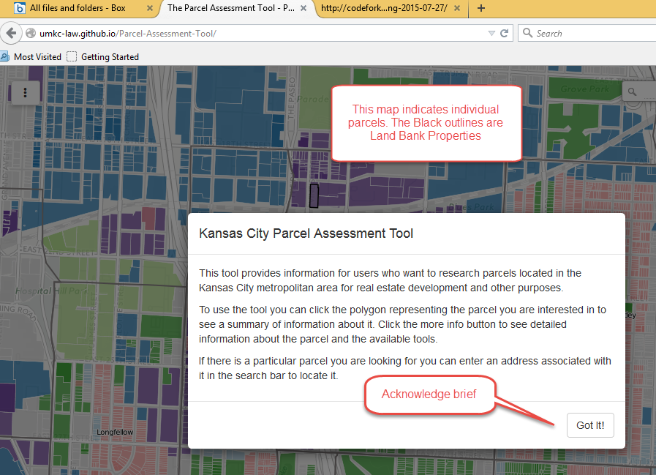

Wendell Phillips

This is the formal Wendell Phillips neighborhood which is the beta test site.

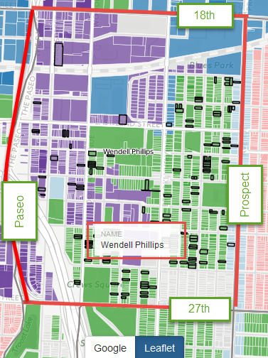

Once a user enters the system they select a site of interest. At this point, only Land Bank parcels are accessible; see black outlines.

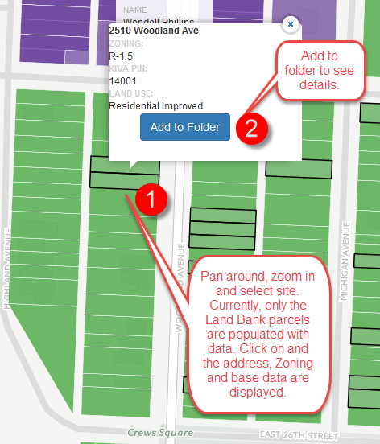

After clicking Add to Folder, additional data are presented.

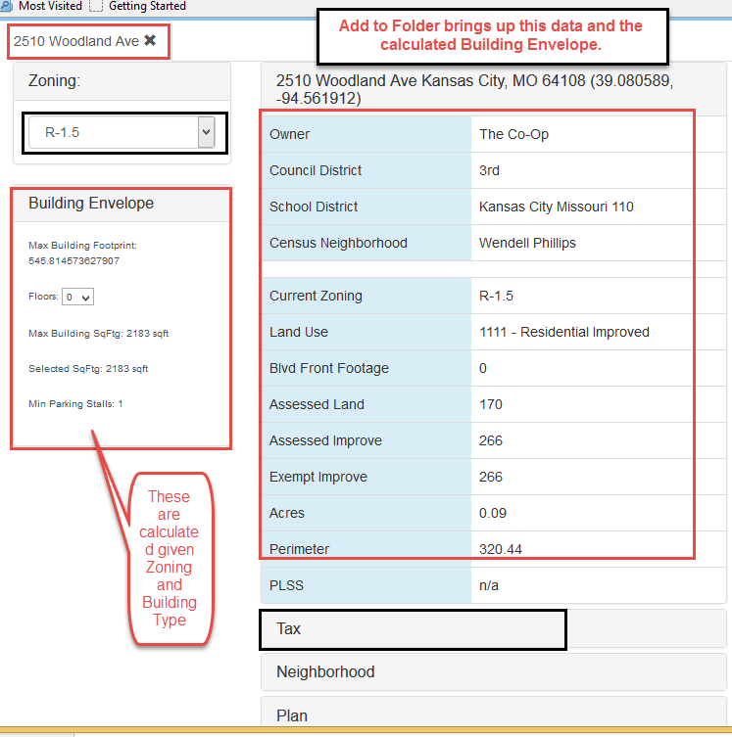

This displays more detailed data as well as the calculated Max Building Envelope (Max Building) in the lower left. The maximum is determined by a combination of zoning (e.g., lot coverage, Floor-area-ratios, height, and parking), land use, and building type variables. These are all extracted from the underlying data and geocoded to the site.

The two Black areas (i.e., Zoning and Tax) are interactive. With the Zoning, the user can select a different type from the drop-down menu and the BEmax is automatically recalculated.

Interactive Zoning and BEmax

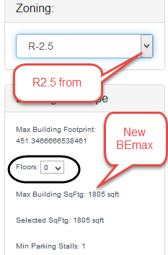 Note that in this example, the max building is 1,805 sf vs. 2,183 with the initial zoning. This feature allows a user to determine the impact of a change in zoning or a zoning variance. The Floors is another variable which can be changed by the user since the user might not want to use the maximum height allowed for in the zoning.

In addition to the core data, PDAAT provides access a growing number of variables.

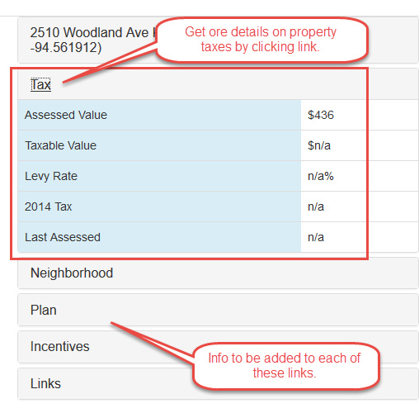

Josh and Ron. At this point the beta version has some bugs. The data screen cannot be collapsed in the current version. The only way to clear the screen back to the map is to use the Back Button and that starts you all over.